24th April 2008
Tena koutou

I hope you had a well deserved and refreshing break after a busy first term.

Introduction
As many of you will be aware I have been appointed as Practice Leader RTLB.

My role will be to support you in your work to achieve better outcomes for students with moderate learning and/or behaviour needs. My intention at this stage is to gain an idea of what the practice issues are for each area. Over the next few months I hope to visit as many RTLB clusters as possible. From there I will be able to prioritise key practice issues across the country for RTLB and develop strategies to support your practice.

My background is in teaching, both in the private and state sector. I trained at Palmerston North Teachers’ College then taught for ten years in New Zealand then London. My experiences in the London education system provided many opportunities to work alongside children with special needs. When I returned to New Zealand I developed my interest further by working as an RTLB and completing the required training. I worked in two RTLB clusters in Auckland for four years. I continued my study and was employed as an educational psychologist by the Ministry of Education, Special Education first in Auckland then in Hawke’s Bay. While in these positions I participated in RTLB management committees and provided support and guidance to specific clusters.

RTLB are professional leaders and advocates of effective teaching and learning.
Your practice is essential to the success of children and young people and their whānau, regardless of whether you are providing individual, class or whole school interventions. I am looking forward to working alongside you and supporting your work.

This letter will be the first in a series that accompanies publications relevant to your RTLB role. If your details have changed or you are know of other RTLB who have missed out on this pack please email rtlb.project@minedu.govt.nz.

New Zealand Autism Spectrum Disorder Guideline
Some of you will be aware of the recently published NZ ASD Guideline, a single, credible source of international and NZ evidence, experience and practice in supporting people with ASD. We expect the information in the Guideline will help improve services for people with ASD, their families and whānau and you can expect to be asked how your advice matches with what is in the Guideline. Included in this letter is your copy of the NZ ASD Guideline Summary. Also included are five flyers for you to pass on to principals, SENCO, teachers and others. The flyers explain how to request further copies of the NZ ASD Guideline. There is no charge for these resources, so please do encourage everyone to get their own copies. I will provide regular updates on Guideline-related developments.

Ministry of Education Library
As you know, the Ministry of Education Library is now available to RTLB. The library is a fantastic resource for books and articles. It’s encouraging to know that more than 500 RTLB have joined the library and are using it to receive the latest research on learning and behaviour issues. Enclosed in this letter is a brochure about the services offered. For more information please email education.library@minedu.govt.nz.

2008 Annual Reporting
Carmel Hoetawa (National Co-ordinator RTLB) and Nicola Borgfeldt (RTLB Advisor) have asked me to advise you that the 2008 Annual Report form is available for download on the TKI website. All information in Parts A, B and C should be completed by the end of Term 4 2008. RTLB should collate the data collected for the cluster over the year to complete Parts A and B. Each RTLB is required to complete Part C. This is available as separate download. Parts D and E must be completed by Friday 29 May 2009 and the report signed off by the Fundholder and the Cluster Convenor. They are due at the nearest Ministry of Education local office on 5 June 2009. Any queries about the Annual Reporting requirements or form can be directed to rtlb.project@minedu.govt.nz. The forms are available at http://www.tki.org.nz/r/governance/rtlb/reports_e.php.

Naku noa, na

Angela Litterick-Biggs
Practice Leader RTLB

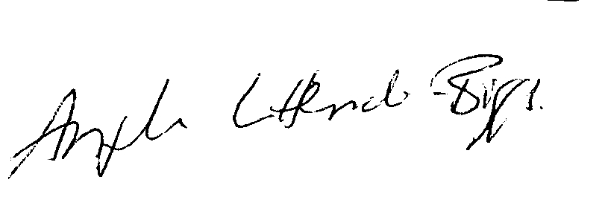

Professional Practice
PO Box 1666 45-47 Pipitea Street Thorndon Wellington 6140
Tel: 04 463 8801
Cel: 021 817 637
Fax: 04 463 8254
Email: angela.litterickbiggs@minedu.govt.nz

